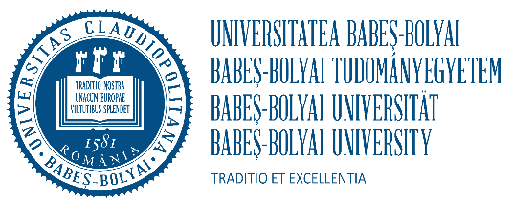
BABEŞ-BOLYAI UNIVERSITY CLUJ-NAPOCA
CENTRE FOR INTERNATIONAL COOPERATION
68, Avram Iancu St., RO – 40 0083, Cluj-Napoca, România
Phone. +40/264/429762 Fax: +40/264/429755
E-mail: ilona.dranca@ubbcluj.ro, ramona.onciu@ubbcluj

STAFF APPLICATION FORM
ACADEMIC YEAR 2022/2023 Erasmus+ with partner countries

This application should be filled in ELECTRONICALLY. You are kindly asked to fill in ALL the fields!

PERSONAL DATA

First name:

Last name:

Nationality:

E-mail:

SENDING INSTITUTION

Name: University of Banjaluka, Faculty of Mechanical Engineering

Address: Stepe Stepanovića 71, 78000 Banjaluka, Republic of Srpska, Bosnia and Herzegovina

ERASMUS code of the home university: PIC 922160571

Position at the home university:

Home Faculty/Department:

E-mail: info@mf.unibl.org

Phone: +387 51 433 000

DATES of visit (day/month/year): 02.07.2024./to/08.07.2024.
TYPE: Erasmus – teaching mobility ( ) Erasmus – training mobility ( )

Other ………………………………………………………

RECEIVING INSTITUTION

Host university: Universitatea Babeș-Bolyai

Erasmus code: RO CLUJNAP 01
Host Faculty/Department: Faculty of Mechanical Engineering, Department of Engineering Science, Resita

Contact Person:……Ilona Diana Drancă

E-mail: ilona.dranca@ubbcluj.ro

- Teaching programme

Topic | Duration (hours) | Level | Teaching language | Number  of students

- Training programme / Other

Date | Activity

Date and Place Signature

